Spring 2025
Cse-5392 wireless Communications
the university of texas at arlington


lab 2 report
Submitted toward the partial completion of the requirements for CSE 5392
Under the guidance of
Prof. Jason Losh
By:
Dario Ugalde, 1001268068

Introduction
This lab expands on the corresponding topics covered in class and explores the effects of clipping on external sources and compression of single and dual tone inputs. It builds on the software and hardware developed in the previous lab. The required changes will be described in more detail in the following section.

Steps 1 – 8: Clipping
The lab begins with specific instructions on how to connect the RF electronics with an amplifier and how to provide without damaging any of the devices. Following these instructions, the devices were wired to the red board and lab circuit from lab 1 to provide the IQ external sources for this part of the lab.
The software for the red board from lab 1 was modified to provide for a clipping function. This was accomplished by adding a new command to our user shell. The command would accept a uint16_t value which would be used to limit the peaks of the sinusoid outputs. For our setup, we found that dropping the peaks and raising the troughs by 100 units of the DAC outputs would decrease by 50mV. This step size would be used for step 8 where a table of dBm values was measured to visualize the impact of clipping on an RF system.
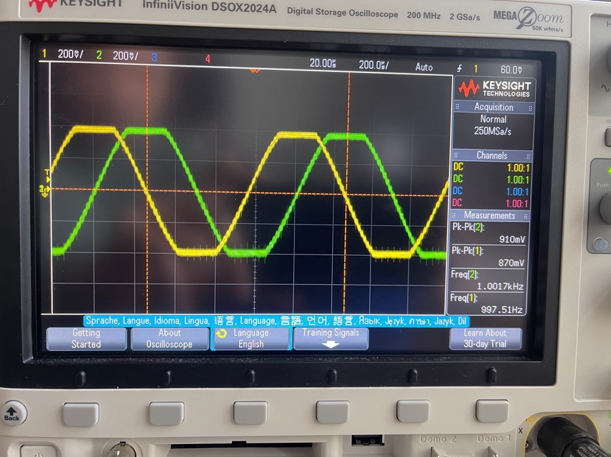
Figure 1. Oscilloscope capture of clipped IQ sources
For the purposes of this lab, these clipped signals represent scenarios where the IQ sources have become distorted which can happen due to amplifier compression as shown in upcoming sections of the lab. It is important to note, this negatively impacts RF systems as it results in reduced and inefficient performance. In class, mitigation strategies were discussed where a system could be implemented with a known headroom to prevent these distortions. The following images contain spectrum analyzer outputs which demonstrate how clipped signals create unwanted frequencies through harmonic distortions.
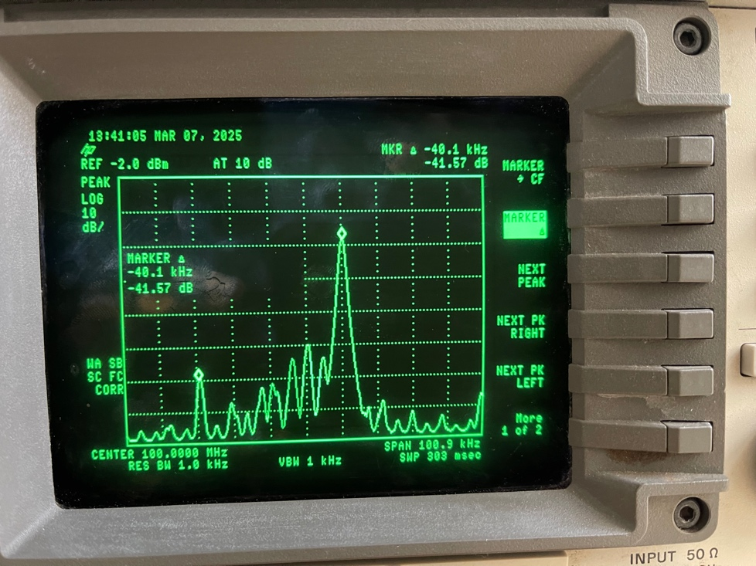
Figure 2. Spectrum analyzer capture with no clipping applied to IQ sources
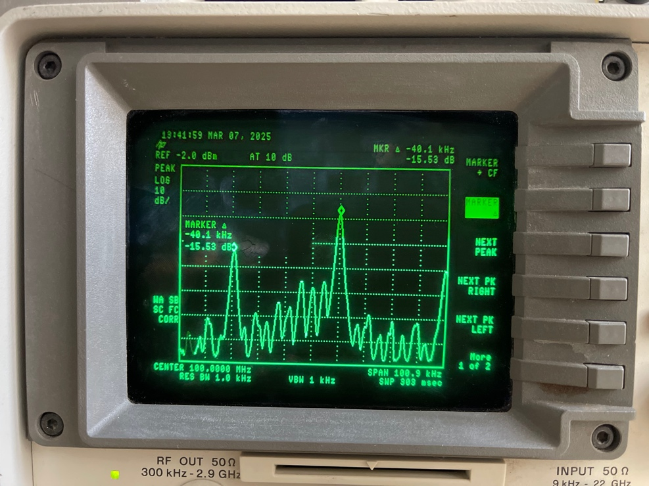
Figure 3. Spectrum analyzer capture with 750mV clipping applied

Clipping Values Captured in Lab
clip val (mV) | dB
0 | -43
50 | -31.3
100 | -27
150 | -24
200 | -21.5
250 | -20.75
300 | -19.2
350 | -18.5
400 | -18.2
450 | -18.2
500 | -18
550 | -18
600 | -17.8
650 | -17.2
700 | -16.5
750 | -15.5
800 | -15.4
850 | -18

Steps 9 – 20: Compression with Tone Input
For the next steps of the lab, an SPF5189Z with a 20dB pad is added between the RF generator and the spectrum analyzer. The generator was configured to start with -20.0dBm amplitude and a table was produced that demonstrates the amplifier’s compression point. The images below demonstrate how increasing the dBm amplitude from the signal generator is increased over time, the compression point can be determined. For our purposes, there appeared to be a slight offset of 0.75dBm when first powered up. We had to keep this in mind as we calculated our compression. For this setup, we found the compression point of the amplifier at around 2.0dBm output from the RF generator. The calculated data points can be seen in the table below. This is approximately in line with the 22.7dBm compression point specified in the part’s datasheet, again bear in mind we started with a 0.75dBm offset, so for our setup, this makes sense. (For convenience, a snip of the document is shared below.)

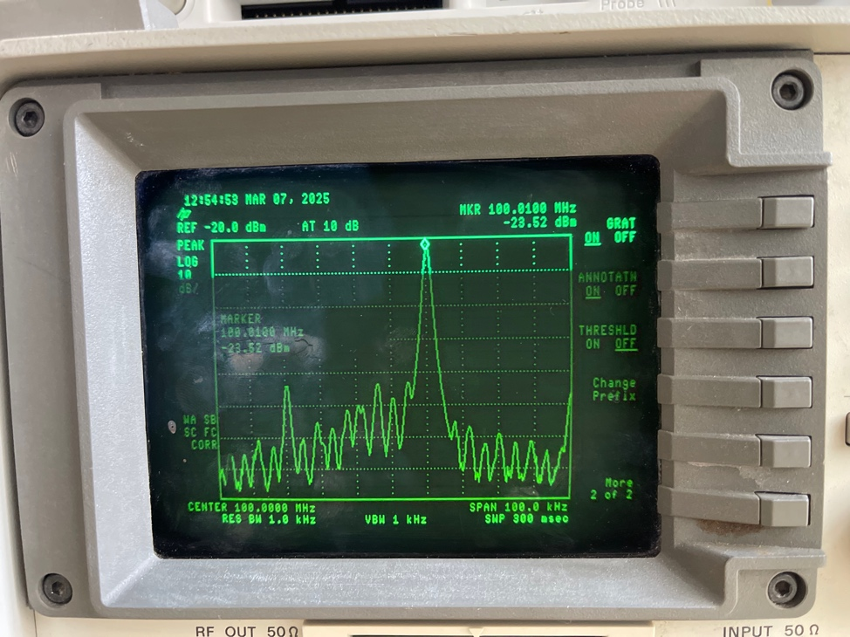
Figure 5. Spectrum analyzer capture of the single tone baseline output at -20.0 dBm

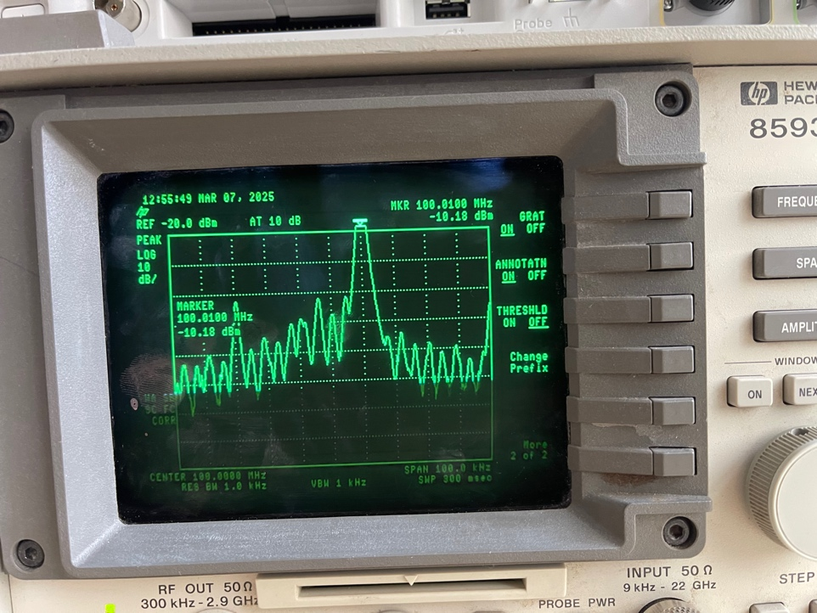
Figure 6. Spectrum analyzer output of the modified RF output to search compression point

Single Tone Amplitude Values Table
RF dBm | Spectrum dBm
-20 | -19.22
-19 | -18.25
-18 | -17.25
-17 | -16.25
-16 | -15.25
-15 | -14.25
-14 | -13.25
-13 | -12.25
-12 | -11.25
-11 | -10.25
-10 | -9.3
-9 | -8.3
-8 | -7.3
-7 | -6.32
-6 | -5.33
-5 | -4.36
-4 | -3.4
-3 | -2.4
-2 | -1.4
-1 | -0.56
0 | 0.04
1 | 0.3
2 | 0.25

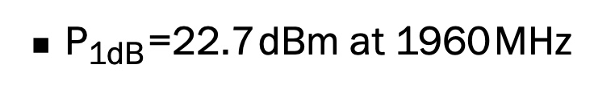
Figure 4. Compression point of the SPF5189F as shown in the datasheet

Steps 21 – 32: Compression with Two Tone Input
This final portion of the lab was a repeat of the previous lab with the Q source disabled. This resulted in a dual tone output as shown below. The same process as with the single tone output was repeated to build a table. For this portion, note we started with a 2.25dBm offset. This resulted in a compression point around -1.0dBm. When working with dual tone signals provided to an amplifier tests the creation of unwanted frequences, known as intermodulation distortion (IMD).
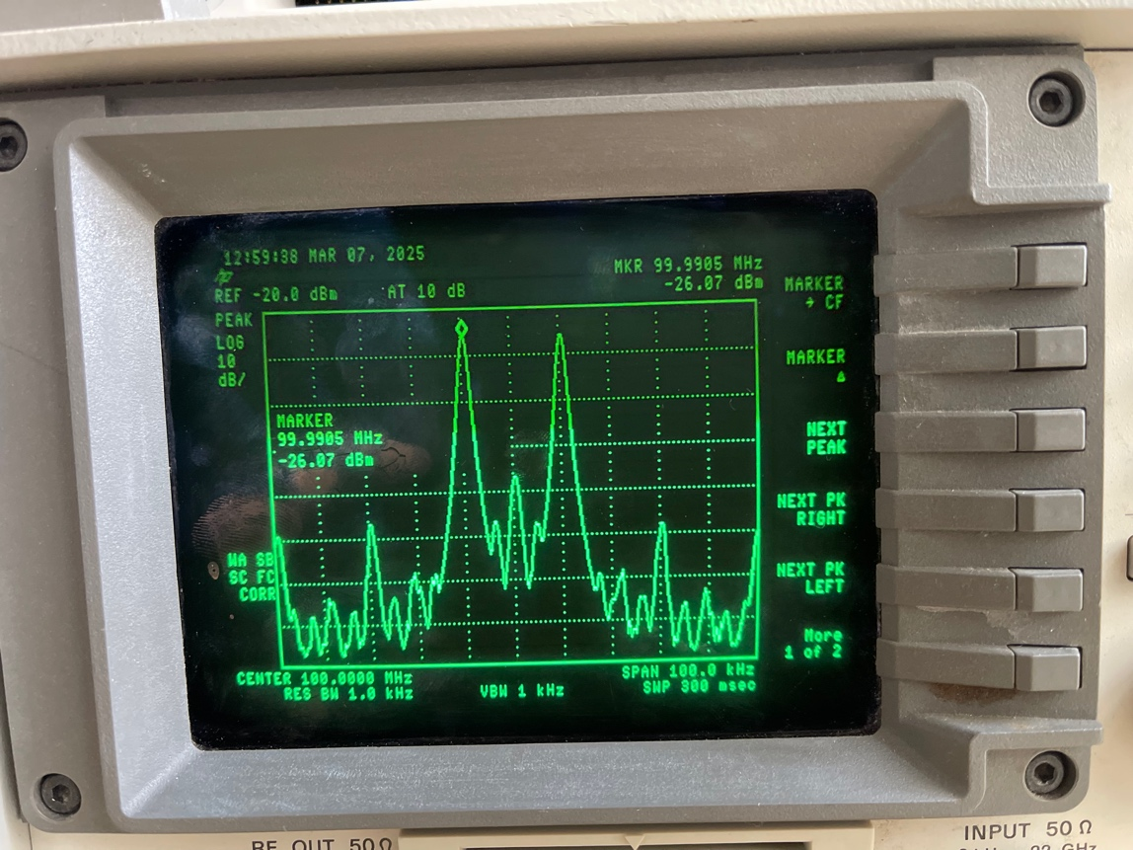
Figure 7. Spectrum analyzer capture of the baseline -20.0 dBm output

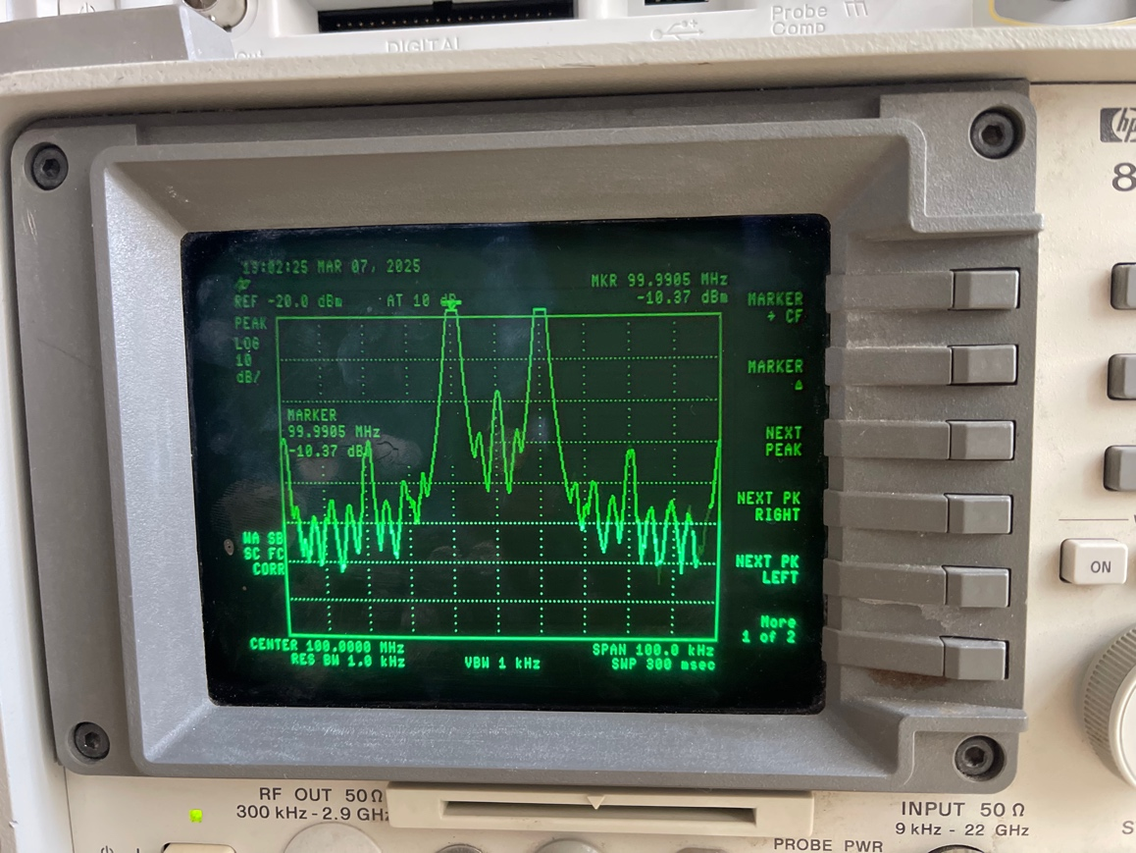
Figure 8. Spectrum analyzer output with a modified dBm output

Dual Tone Amplitude Values Table
RF dBm | Spectrum dBm
-20 | -22.25
-19 | -21.26
-18 | -20.25
-17 | -19.25
-16 | -18.3
-15 | -17.3
-14 | -16.3
-13 | -15.3
-12 | -14.3
-11 | -13.3
-10 | -12.3
-9 | -11.3
-8 | -10.35
-7 | -9.35
-6 | -8.4
-5 | -7.4
-4 | -6.5
-3 | -5.6
-2 | -4.96
-1 | -4.5
0 | -4.3

Conclusion
In summary, this lab provided a practical example of the impact clipping has on degrading RF systems. Additionally, we identified the compression point of a given amplifier for single and dual tone outputs. The reason understanding these compression points are important is tied to the effects of clipping. As more performance is expected of an amplifier than it can provide, the system will exhibit reduced performance. These are important topics to keep in mind while working with RF systems in the future. The following images are captures of the setup used to validate our attendance of the lab.

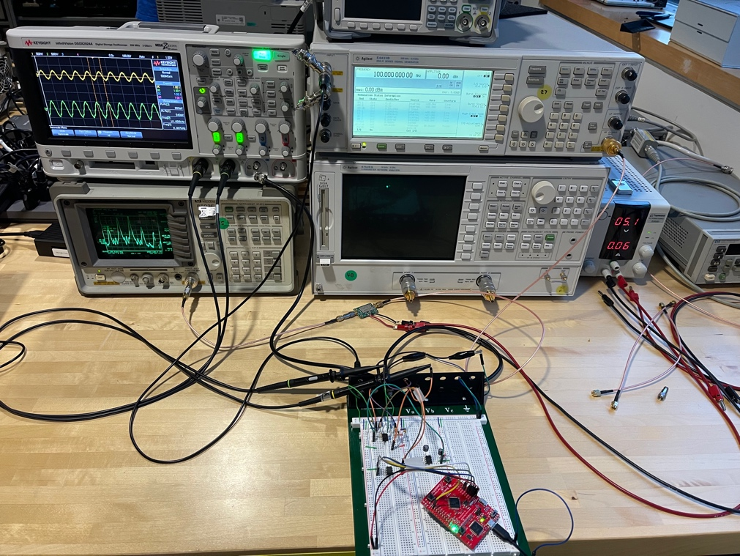
Figure 9. Lab configuration as used for lab 2
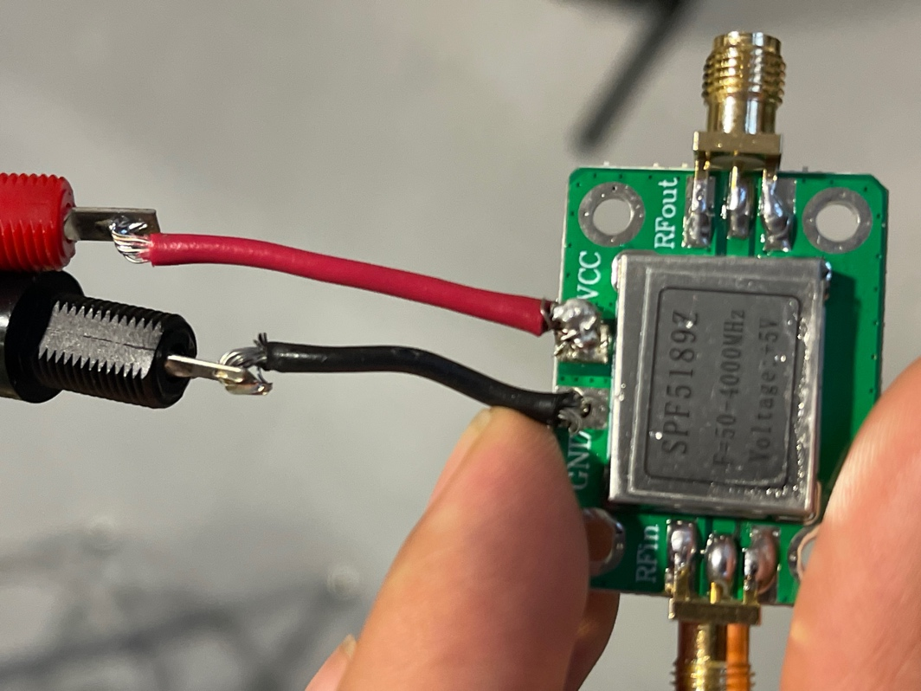
Figure 10. Close-up of the SPF5189Z amplifier used for the second half of lab

